***Statue of a silent man***

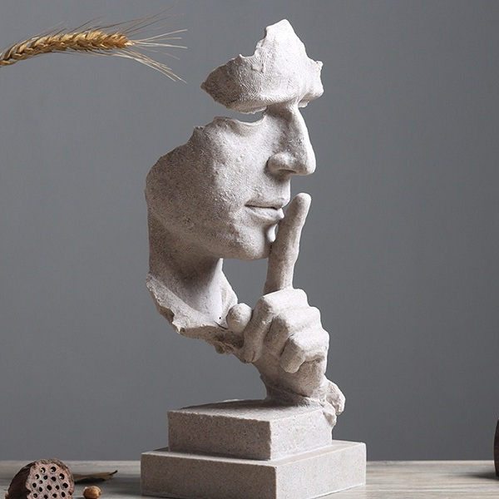

*The silent human face statue is made of artificial stone. The silent human face statue is suitable for decoration, housewarming gift, boss gift, teacher gift*